SPARK: Simple Play Adaptations to Reference for Kids

Sensational Texture Activity Center
Description: | Image:
The Sensational Textured Activity Center includes mirrors, fans, music, songs, lights, sound effects, and spinning beads to offer a variety of textures, sights, and sounds that are activated by pressing one of six large activation plates each with a different texture and color. Children can use the Activity Center to engage in both independent and parallel play since it is in a multi-sided configuration. This product is like a conventional busy box that is commonly used by young children to explore a collection of colorful and varied textured objects that are stabilized to a board. | 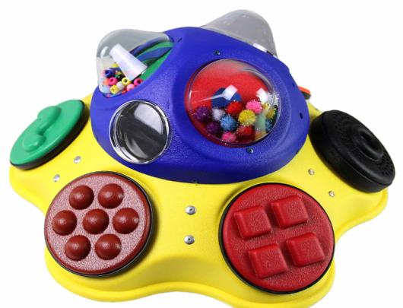  Purchasing Information  User’s Manual

Who Might Benefit?
Those who…
• Struggle or are frustrated by manipulating small objects.
• Have limited mobility or ability to move into and out of various positions during play.
• Need to further develop reaching, targeting, and hand eye coordination.
• Need engaging visual and auditory materials to support attention to task.
• Have visual impairments and benefit from engaging in high contrast-colored objects.

Why Use?
Provides an opportunity to…
• Explore a collection of colorful, varied textured, and sound producing objects.
• Engage in directed reach and fine motor activities.
• Gain an understanding of simple cause and effect.
Instructions for Use: | Adaptation Ideas:
Environmental Considerations  - Use in any environment including community, home, and school. The product does have lights and sounds which may be disruptive in quiet environments.  Positioning  - Tabletop: Set up on a table or similar surface so the user can play while sitting or standing.  - Floor: Place on the floor to use in a variety of positions such as tummy time positions and side lying.  Alternate Positioning  - Slanted: Place on slanted surface such as a 3-4-inch 3 ring binder to help with viewing and reach. A slanted surface may help children view the toy or activity and/or reach the entire toy.  Basic Play/Use  - Place in front of the child within easy reach for free exploration of the activation plates and activities to support cause and effect learning.  Extended Play/Use  - Ask the child to touch and interact with specific activities (e.g. make the fan go, push the button to make the glitter move, turn on the multi-colored lights, etc.).  - Ask the child to reach toward various color activation plates to turn on an activity (e.g. push the red button, push the blue button, push the green button, etc).  - Ask the child to name the color of the activation plate they are pressing.  - Ask the child to describe the texture of the object (e.g. the button is bumpy, the button is smooth, the button is vibrating, etc.).  Play/Use with Others  - There are multiple items and sides on the Activity Center that would allow at least 2 children to play together either taking turns or engaged in parallel play. | Optional Additional Materials/Supplies  - Dycem or cabinet liner  - Sticky shelf paper  - Velcro  Stabilize It  - If the child is having difficulty controlling their reach you could encourage the child to rest their forearm on the table while engaged in the activity which requires less control than using the entire arm.  - Dycem could be used under the Activity Center to keep it in place on a table or Velcro could be used on the back of the Activity Center to attach it to the carpet if used on the floor.  Simplify It  - Some of the objects could be covered with a dark cloth to limit the number of choices made available to the child for exploration. They can be revealed one at a time for full exploration of each item separately or they can be revealed in any combination.  Add Sensory Cues  - All activation plates on the activity center have unique tactile cues either through texture or the touch exploration and interaction with the activity. Additional stickers, puffy paint, or other tactile cues could be added if needed.  Communication Support  - Provide a communication board with vocabulary appropriate for the various Activity Center activities. (e.g. more, I like …., stop, help, etc.).  DIY Alternatives  - Build a toddler busy board with items you already have

Additional Considerations:

For children with auditory sensitivities, it should be noted there are sounds that accompany many of the activities.

For children with visual sensitivities, select items on the activity centers could be covered to reduce visual distraction or sensitivities.

Requires 6 C batteries. Weight 6-1/2 pounds. Size: 17-1/2 x 8-1/2 inches

Ohio Early Learning Standards:
- AL: Engagement and Persistence: Engages in new and unfamiliar experiences and activities (1.a.).
- AL: Engagement and Persistence: Persists in completing a task with increasing concentration (1.c.).
- CO: Problem Solving and Reasoning: Develops ability to be flexible in own thinking and behavior (4.a.).

Words to Encourage Play/Use
Push  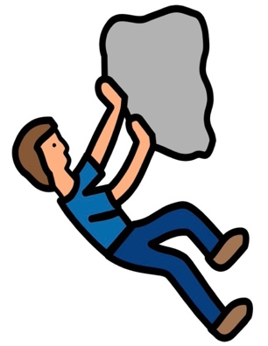 | Reach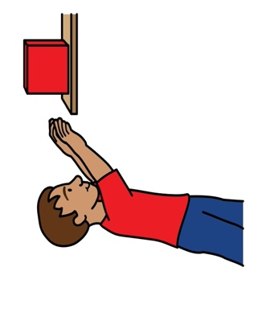 | 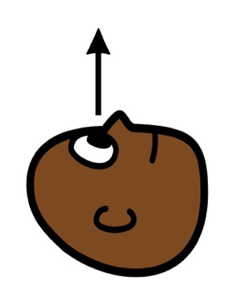  Look
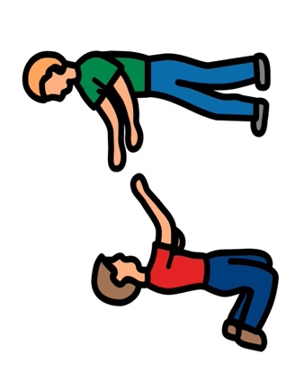  Help |   Like | 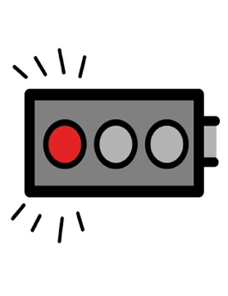  Stop
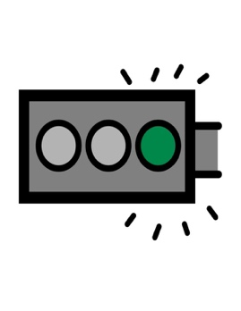  Go | More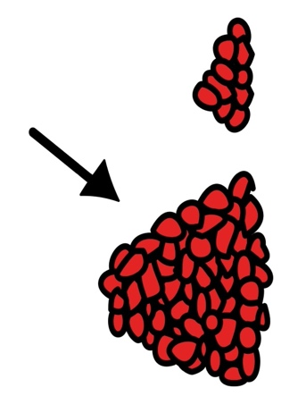 | Done  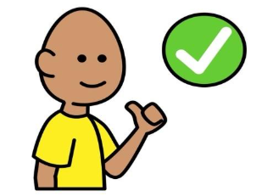
*”Adaptations” adapted from: Haugen’s Modes for Adapting Toys based on materials from the "Let's Play" Project at the University of Buffalo
PCS is a trademark of Tobii Dynavox, LLC. All rights reserved. Used with permission.

